Home Work 1

Part1

|  |  |
| --- | --- |
| Row | Time(seconds) |
| 3600 | 45 |
| 7200 | 52 |
| 10800 | 64 |
| 14400 | 79 |
| 18000 | 100 |
| 21600 | 126 |
| 25200 | 157 |
| 28800 | 188 |
| 32400 | 228 |
| 36000 | 271 |
| 72000 | 928 |
| entire | See Blow |

Our graphic looks like:

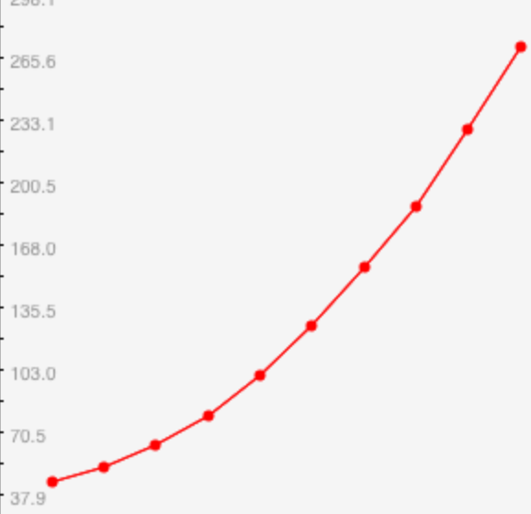 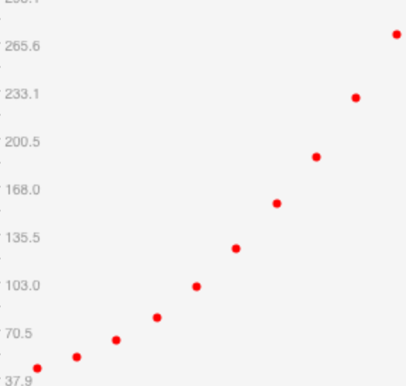

Our function at here looks like: quadratic

Big O notation at here is Θ(n) = O($n^{2}$)

At very beginning, the run time between linear and quadric, but if we see from 36000 to 72000, it is a quadric.

Our file has 360000000 (36million) lines, the total time should be:

Total time = ${(\frac{36000000}{72000} )}^{2}$* 928 = 232000000 (seconds) = 7.35667 years.

Part2

|  |  |
| --- | --- |
| Row | Time(seconds) |
| 3600 | 42 |
| 7200 | 44 |
| 10800 | 49 |
| 14400 | 58 |
| 18000 | 65 |
| 21600 | 74 |
| 25200 | 85 |
| 28800 | 100 |
| 32400 | 116 |
| 36000 | 132 |
| 72000 | 539 |
| Entire | See Blow |

Our graphic looks like:

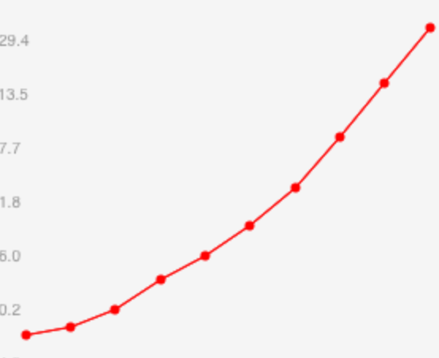 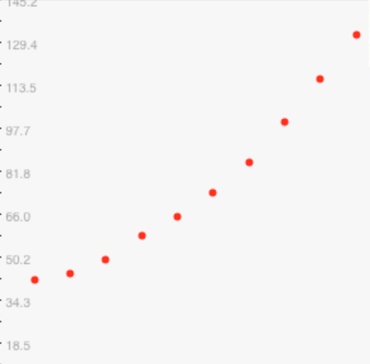

Our function at here looks like: quadratic

Big O notation at here is Θ(n) = O($n^{2}$)

At the very beginning, our run time function looks like a linear function, but from 36000 to 72000, it looks like quadric

Our file has 360000000 (36million) lines, the total time should be:

Total time = ${(\frac{36000000}{72000} )}^{2}$* 539 = 134750000 (seconds) = 4.27289 years.

There are some problems for me to get the CPU memory requirement in monsoon.

Here is my test output:

Part1:

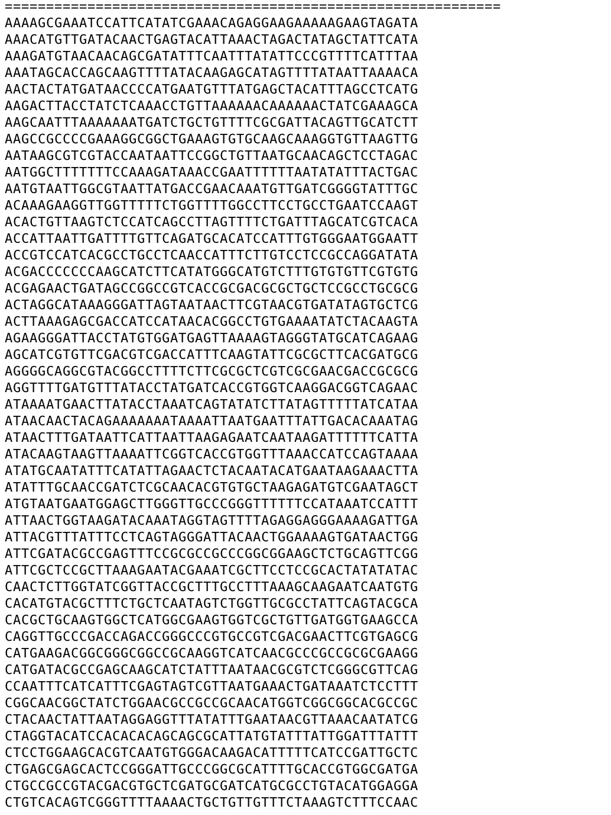

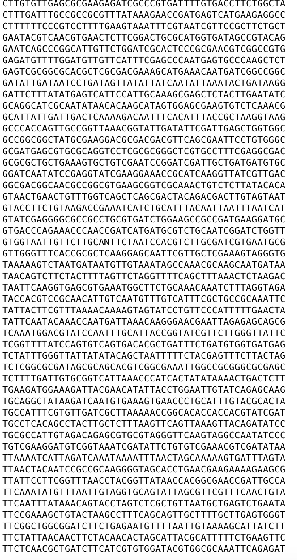

Part2:

